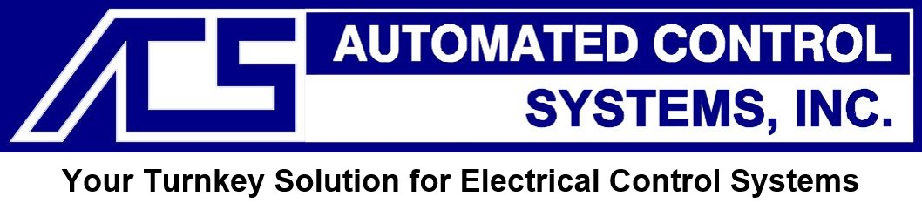
23659 Industrial Park Dr. ~ Farmington Hills, MI 48375
Ph:(248) 476-9490
www.autoconsys.com

ELECTRICAL CONTROLS ENGINEER

Full-time position
Job Description:
We are looking for a motivated Electrical Controls Engineer who is eager to join our team. You will contribute to multiple aspects of projects including planning, design, documentation, programming, purchasing, integration, testing, training, and commissioning work of electrical control systems. The ideal candidate is someone who possesses a creative and customer-focused mindset with the drive to tackle any issue that comes their way.
To be successful in this role, you must provide direction, technical expertise, and effective communication to the project team. In addition, you have the ability to utilize strong analytical skills to resolve complex technical challenges. Self-directed and outcome-oriented in achieving ambitious project goals.
Job Responsibilities:
Core:
- Work with staff personnel and customers to design and develop turnkey control systems per project requirements.
- Interface with field personnel and purchasing to determine and obtain required bill of material.
- Coordinate project requirements with the project manager.
- Visit manufacturing/vendor sites to inspect and test components.
- Effectively work with and communicate with our customers to ensure a seamless delivery.
- Understand scope of work, sequence of operations and effectively communicate deviations from scope of work to management for issuance of Engineering Change Orders (ECO)
- Monitor & assess all aspects of design, implementation, installation & commissioning of the control system.

Experience related:
- Generate and release electrical schematics and control panel layouts.
- Hardware design & development
- Design, maintain and update controls documentation, print packages, BOM’s, etc
- Participate in trouble shooting: investigate and resolve issues.
- Start-up / debug and commissioning, locally and out-of-state, at final customer site for various types of equipment.
- Develop, design and modify controls software packages including: Programmable Logic Controllers (PLC), Human/Machine Interfaces (HMI), and Personal Computer Based systems (PC)

Job Qualifications:
Basic:
- A minimum of 3-5 years working experience in electrical engineering
- Excellent communication & interpersonal skills
- Ability to comprehend all details required to complete a project to the customer specifications, start to finish.
- Experience in controls engineering for a project from scratch.
- Ability to manage multiple projects independently and in a team setting.
- Willingness to work overtime as required.
- Willingness to travel - 10-25% should be expected.
- Ability to keep up with changing customer specifications.
- Ability to develop and apply standard controls philosophies.
- Detail oriented & willingness to be part of a successful team.

Preferred:
- Bachelor’s in Electrical Engineering or related field (preferred)
- Minimum of 3 years’ experience with one brand of controls software (preferred Rockwell or Siemens)
- Detailed knowledge of process controls, relay logic, and PLC programming
- Minimum of 1 year experience with “Eplan” or “AutoCAD Electrical” drawing software.
- Knowledge of both electrical and pneumatic schematic symbols

* Starting Pay: $30/hr and up; depending on experience

