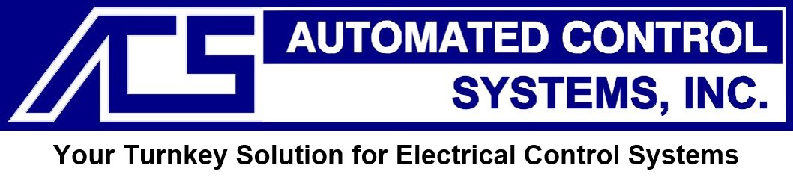
23659 Industrial Park Dr. ~ Farmington Hills, MI 48335
Ph:(248) 476-9490
www.autoconsys.com

SALES ENGINEER / ACCOUNT MANAGER

Full-time position
Job Description:
We are looking for a highly motivated Sales Engineer / Account Manager who is eager to join our team. You will be responsible for developing long-term relationships with customers, driving sales, managing customer accounts, and providing technical support throughout the sales process.
As a Sales Engineer / Account Manager, you should work to satisfy customers’ needs and requests, respond to their queries in a timely manner and aspire to deliver a positive customer experience. You should have excellent communication and negotiation skills and be customer service oriented.
Ultimately, you should be able to grow our business by building a successful, long-term client relationship.
Job Responsibilities:

- Effectively demonstrate the ability to work with customers, management, engineering and purchasing to promote, support and sell solutions
- Generate new sales using existing customers as well as developing new customers and markets in Engineering, Panel Build and Field wiring
- Developing positive relationships and handling customers’ needs; making frequent/regular visits to determine ongoing needs and providing proposals that fulfill the customer’s requirements
- Consolidate all details and requirements needed to prepare and organize proposals with cost and delivery expectations; generate sales agreements
- Work with the project team to ensure projects meet/exceed customer expectations when delivered
- Set, track and report sales activities to senior management on a regular basis
- Assist senior management with quarterly sales targets and work to achieve targets
- Demonstrate ability to learn and manage the entire sales processes efficiently
- Overall Portfolio / Project Management

Job Qualifications (Core):
- Detail oriented and self-directed
- Excellent communication (verbal and written) & interpersonal skills
- Ability to negotiate

- Ability to manage multiple projects independently and in a team setting
- Ability to keep up with changing customer specifications

Preferred:
- 2-3+ years’ experience working in Sales; added value if in the automation and industrial controls business environment
- Proven track record in sales growth and consistently achieves revenue targets
- Practical experience as a Sales account manager responsible for managing a portfolio of accounts to achieve long-term success
- Knowledge and use of MS Office (MS Excel, Word, and Power Point)
* Starting Pay: Salary + Commission on orders sold

